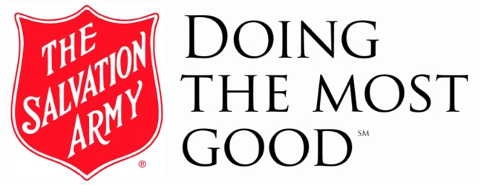
THE SALVATION ARMY
NORTHERN DIVISION
2445 Prior Ave N, Roseville, MN 55113
SalvationArmyNorth.org
Facebook.com/SalvationArmyNorth
Twitter.com/SalArmyNorth
Instagram.com/SalArmyNorth

FOR IMMEDIATE RELEASE – February 6, 2026

Contact: Joanne Johnson Lee, Service Extension Director
651-746-3406 (o) • 000-000-0000 (m) • joanne.johnsonlee@usc.salvationarmy.org

Salvation Army Launches “SAHelp” Program to Strengthen Social Services Across Minnesota and North Dakota

[ROSEVILLE, Minn.] – The Salvation Army Northern Division is proud to announce the implementation of a new digital case management and communications platform, SAHelp, rolling out across several counties in Minnesota (Pine, Isanti, Rice and Steele) and North Dakota (Stutsman, Ramsey, Benson, and Towner). Designed to streamline social services operations while enhancing client experience, SAHelp will significantly improve efficiency, compliance, and outreach—allowing The Salvation Army to better serve individuals and families in need.

Caseworkers in today’s nonprofit environment face growing demands, from high caseloads and staffing shortages to complex compliance requirements tied to grants and funding. SAHelp directly addresses these challenges by automating administrative tasks and centralizing client intake, documentation, and communication into one easy-to-use platform.

“SAHelp allows our caseworkers to spend less time on paperwork and more time doing what they do best—helping people,” said Joanne Johnson Lee, Salvation Army service extension director. “By improving productivity and reducing stress on staff, we can extend our reach and increase the impact of every dollar entrusted to us by donors and partners.”

Early implementation results show SAHelp can reduce case processing time by 40 to 60 percent. This productivity boost not only improves workflow but also creates substantial cost savings—potentially up to $54,000 annually per caseworker—allowing funds to be redirected into expanded services and greater community support.

For clients, SAHelp offers a more accessible and compassionate experience. The applicant-friendly interface guides individuals through the intake process quickly and intuitively, reducing confusion and delays. Virtual meeting capabilities eliminate unnecessary travel, childcare challenges, and added stress, making assistance easier to access for families already facing hardship.

SAHelp also strengthens connections between social services and Salvation Army corps programming through real-time text and email communication. Targeted outreach tools allow staff to share information about community events, educational opportunities, and support programs with specific groups—ensuring help goes where it’s needed most.

Compliance is another major advantage. Built-in safeguards help ensure grant requirements are met, reducing the risk of lost or returned funds and protecting The Salvation Army’s ability to secure future resources.

The platform was developed by a team deeply connected to The Salvation Army’s mission, led by CEO and President Paul Booth, who has served both professionally and personally within the organization.

“My lifelong connection to The Salvation Army has shown me how powerful its mission is,” Booth said. “SAHelp was created to support that mission—helping caseworkers serve more effectively and ensuring communities receive timely, compassionate care.”

As SAHelp rolls out across Minnesota and North Dakota, The Salvation Army looks forward to building stronger, more responsive social services that uplift individuals, families, and entire communities—today and for years to come.

# # #

The Salvation Army Northern Division last year helped over 387,000 people overcome poverty, addiction and economic hardship through a range of social services, meeting human needs without discrimination. This year, new struggles caused by food shortages, inflation, increased energy costs and the threat of eviction have elevated the numbers of those seeking assistance.

By providing food for the hungry, emergency relief for disaster survivors, rehabilitation for those suffering from drug and alcohol abuse, and clothing and shelter for people in need, The Salvation Army Northern Division is #DoingTheMostGood at more than 85 operation centers in Minnesota and North Dakota. For more information about The Salvation Army Northern Division, please visit SalvationArmyNorth.org.

