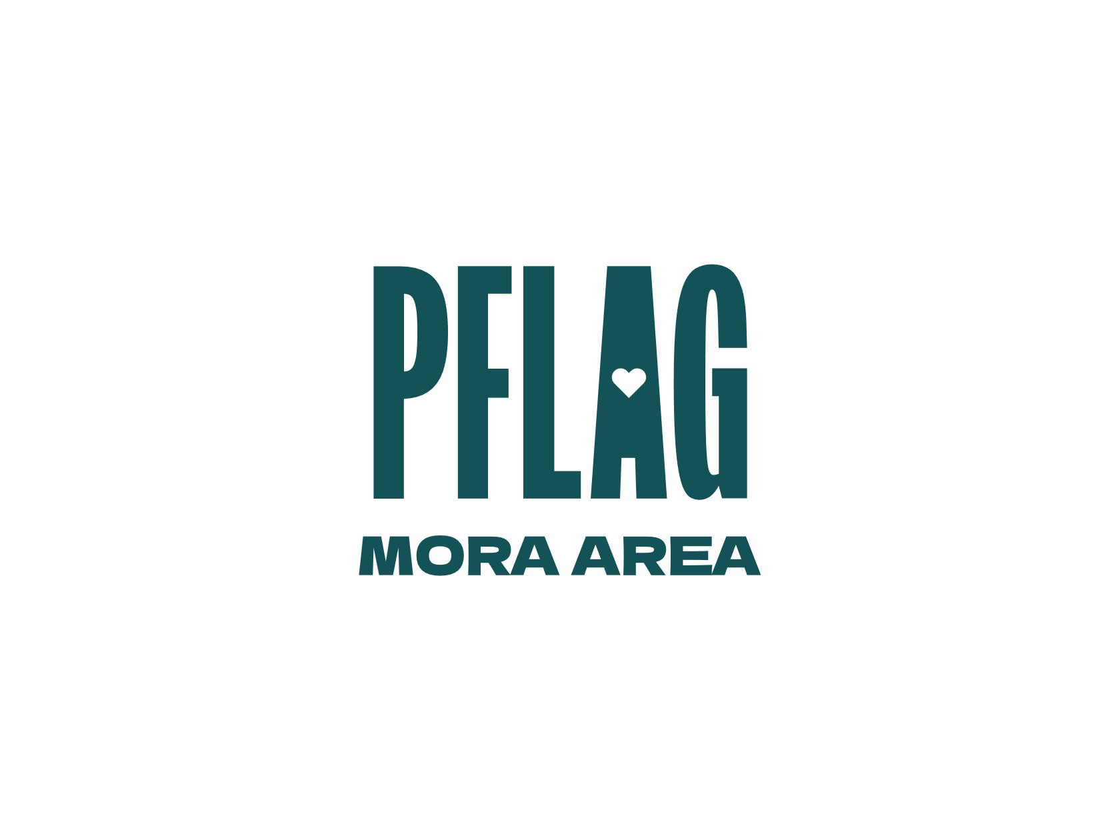
For Immediate Release: 03/23/2026

Phil Schroeder, President
East Central MN/Mora Area PFLAG
320-272-0069
pschroeder54@gmail.com

Non-binary is Topic of PFLAG’s April 19th Event
ECMN PFLAG is hosting an event, “Let’s Talk: An Invitation to Hear from Our Transgender and Non-Binary Community.”

This combination presentation, panel, and discussion will be held Sunday, April 19th, 1-4 p.m., at Common Ground, United Methodist Church, 404 Cypress Street N., Cambridge, MN, 55008.

Inter-active presentations and open dialogue will be structured around the following topics: Trans 101, engaging schools and communities in advocacy, gender’s relationship to mental and physical health, allyship, resources, and shared experiences.

Come with your questions and concerns. Let’s break the myths and stereotypes surrounding our non-binary friends, neighbors and family members. The event is free and open to everyone who is interested in supporting our LGBTQ+ community. Refreshments provided.

Sponsored and organized by East Central MN/Mora Area PFLAG. PFLAG is an organization working to create a caring, just, and affirming world for LGBTQ+ people. We support families, educate allies, and advocate for equality through our network of supporters, members, and chapters across the country.

